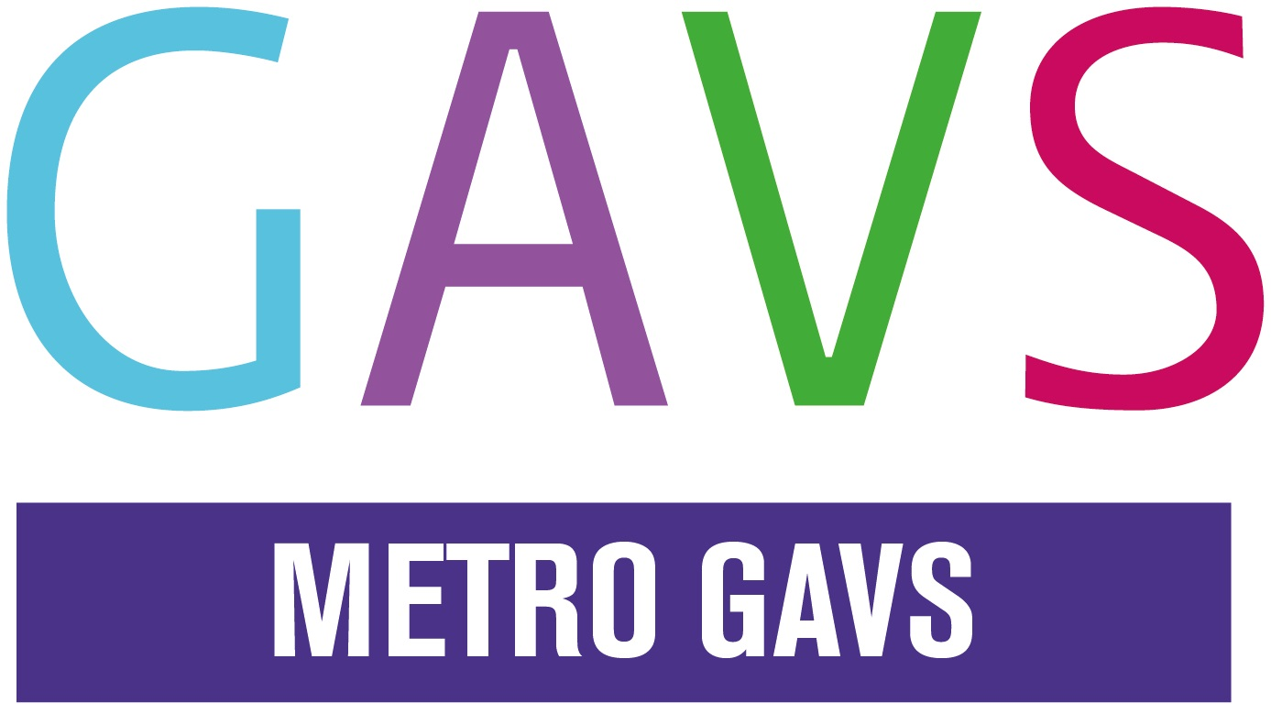
METRO GAVS Training Booking Form
Please complete this form– to be signed by a line manager / authorised individual

Your Organisation
Organisation Name |  | Charity Number (if applicable)

METRO GAVS Non-Accredited Training Course Fees | Cost(per person)
 | Full Day | Half Day
Full Member / Individual Members (+10% online booking discount) | £27 | £15
Non-member / Associate Members / Statutory Private Sector, Voluntary organisations outside Greenwich. (+10% online booking discount) | £70 | £40
METRO GAVS Accredited Training Course Fees | Cost(per person)
Full Member / Individual Members (+10% online booking discount) | £60
Non-member / Associate Members / Statutory Private Sector, Voluntary organisations outside Greenwich. (+10% online booking discount) | £120

Course Title | Date

Contact Details – please complete one form for up to 2 participants
Participant Name/s
Job Title/Role
Address
Contact No.
Participant Email Address/es (course confirmation will be sent to participants email address/es)

Please detail any specific access or support needs that will enable you to participate in the training?

Contact Details
To be completed by authorised individual (if different from above)
Authoriser’s Name
Job Title/Role
Address
Contact No.
Authoriser’s Email Address/es (invoice will be sent to this email address)

If you would like us to send the invoice to a different address or email it direct to your Finance Office enter the contact details below:

Booking Agreement

I have read and agree to the METRO GAVS training terms and conditions and have given authorisation for attendance to the course. I am aware that it is my responsibility to contact METRO GAVS if I do not receive an acknowledgement to this booking. I agree to details being added to METRO GAVS’ database in order that information relating to the bookings can be sent to the relevant participant.
Signature of Authoriser Date
Please return your completed form to:
METRO GAVS, Woolwich Equitable House, 1st Floor, 7 General Gordon Square, SE18 6FH or email: gavs@metrocharity.org.uk

METRO GAVS Training Terms & Conditions
- Booking is essential; delegates will not be admitted if they have not booked online or in writing by email with confirmation of payment.
- A booking fee is required for some training courses. All free training courses require a deposit in advance. The majority of METRO GAVS training events are priced as follows, unless stated otherwise:
METRO GAVS Non-Accredited Training Course Fees | Cost(per person)
 | Full Day | Half Day
Full Member / Individual Members (+10% online booking discount) | £27 | £15
Non-member / Associate Members / Statutory Private Sector, Voluntary organisations outside Greenwich. (+10% online booking discount) | £70 | £40
METRO GAVS Accredited Training Course Fees | Cost(per person)
Full Member / Individual Members (+10% online booking discount) | £60
Non-member / Associate Members / Statutory Private Sector, Voluntary organisations outside Greenwich. (+10% online booking discount) | £120

- METRO GAVS training sessions are advertised on our website and should be booked, using the METRO GAVS website online payment facility. Payment can be made via debit card, credit card or PayPal. Online booking closes a day before each training course; please contact METRO GAVS on 020 8305 5000 to be included on the reserve list.
- Your booking and payment confirmation will be emailed to the email address you provide at the point of booking. Your email order confirmation acts as your booking form. This can also be used as an invoice.
- Where it is not possible to make payment online please complete a booking form and send a completed copy to gavs@metrocharity.org.uk. You will also need to send authorisation from a manager that they are happy to pay for your training course. An invoice will then be sent out via email and you will need to arrange payment via cheque payable to METRO Centre Ltd to be returned before the day of the course. Please include the name of the training and delegate as a reference. Alternative arrangements MAY be considered only with prior approval from METRO GAVS, please telephone for further details.
- Bookings for events will not be confirmed until we receive a completed booking or order form and confirmation of payment.
- To confirm bookings for free training, you are required to complete a booking form and pay a refundable deposit. Your deposit will be refunded upon attendance. Your deposit will not be refunded if you fail to attend.
- Bookings are on a first come first served basis. 2 attendees maximum per organisation can book onto a course. If the course is fully booked, additional attendees can be put on a reserve list. If there are still spaces left 24 hours before the course then the reserve list will be checked and attendees will be contacted and offered a place. Payment for the booking will be arranged.
- Organisations experiencing financial difficulties and unable to pay for a course can write to the Chief Executive using no more than 250 words outlining your case at least 2 weeks prior to the course start date. You need to include a copy of your organisation’s most recent accounts.
- Any cancellation must be received at least 3 working days before the date of the training; otherwise you will be charged the full cost of the course.
- Non-attendance will result in a charge of the full cost of the course.
- Any attendees arriving later than 30 minutes of start time will not be admitted; and will forfeit the fee for the course.
- Refreshments will be available, however lunch is not provided.
- You will receive a Certificate of Attendance upon completion of the course.

To view METRO GAVS Training Programme, please visit www.greenwich-cvs.org.uk/events.
If you have any questions please contact METRO GAVS on 020 8305 5000 or email gavs@metrocharity.org.uk.

